# Interface Sound Sensor with Arduino and Control Devices With a Clap

These sound sensors are inexpensive, simple to use, and capable of detecting voice, claps, or door knocks.

You can use them for a variety of sound-reactive projects, such as making your lights clap-activated or monitoring your pets while you’re away

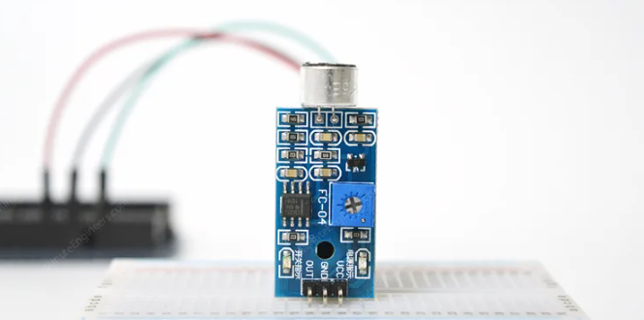

**Technical specification:**

| **Specifications** | **Value** |
| --- | --- |
| Sensor Type | Soil Moisture Sensor |
| Measurement Method | Frequency Domain Reflectometry (FDR) |
| Soil Moisture Range | 0% to 100% (Volumetric) |
| Accuracy | ±3% (typical) |
| Operating Voltage | 3.3V - 5V |
| Output Type | Analog Voltage or Digital |
| Operating Temperature | -10°C to +70°C |

## **Hardware Overview**

The sound sensor is a small board that incorporates a microphone (50Hz-10kHz) and some processing circuitry to convert the sound wave into an electrical signal.

This electrical signal is fed to the on-board LM393 High Precision Comparator, which digitizes it and makes it available at the OUT pin.

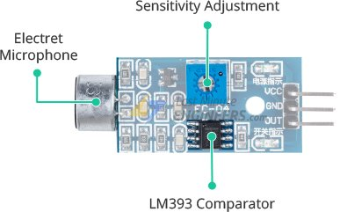

The module includes a potentiometer for adjusting the sensitivity of the OUT signal.

You can use it to set a threshold, so that when the amplitude of the sound exceeds the threshold, the module outputs LOW, otherwise HIGH.

This setup is very useful for triggering an action when a certain threshold is reached. For example, when the amplitude of the sound exceeds a threshold (a knock is detected), you can activate a relay to control the light.

Rotate the knob counterclockwise to increase sensitivity and clockwise to decrease it.

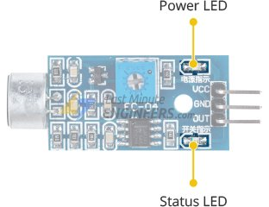

The module also includes two LEDs. The Power LED illuminates when the module is turned on, and the Status LED illuminates when the sound level exceeds the threshold value.

## **Sound Sensor Pinout**

The sound sensor only has three pins:

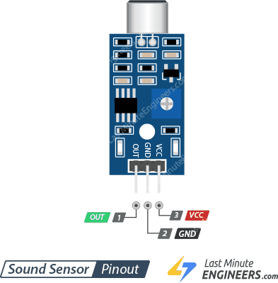

VCC supplies power to the sensor. It is recommended that the sensor be powered from 3.3V to 5V.

GND is the ground pin.

OUT pin outputs HIGH under quiet conditions and LOW when sound is detected. You can connect it to any digital pin on an Arduino or to a 5V relay directly.

## Wiring a Sound Sensor to an Arduino

Let’s hook the sound sensor to the Arduino.

Connections are fairly simple. Start by connecting the module’s VCC pin to the Arduino’s 5V pin and the GND pin to ground.

Finally, connect the OUT pin to Arduino digital pin #8. That’s it!

The wiring is shown in the image below.

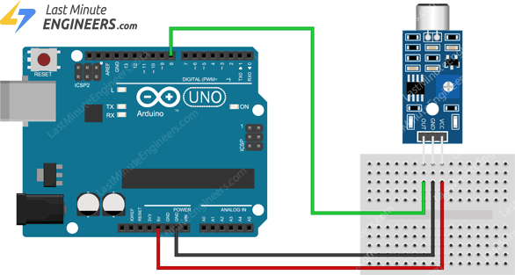

## Setting the Threshold

The module has a built-in potentiometer for setting the sound level threshold above which the module outputs LOW and the status LED lights up.

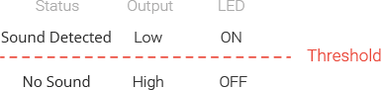

Now, to set the threshold, click your finger close to the microphone and adjust the potentiometer until the module’s Status LED blinks in response to your clicks.

## **Basic Sound Detection**

int ledPin=13;

int sensorPin=7;

boolean val =0;

void setup(){

pinMode(ledPin, OUTPUT);

pinMode(sensorPin, INPUT);

Serial.begin (9600);

}

void loop (){

val =digitalRead(sensorPin);

Serial.println (val);

// when the sensor detects a signal above the threshold value, LED flashes

if (val==HIGH) {

digitalWrite(ledPin, HIGH);

}

else {

digitalWrite(ledPin, LOW);

}

}

